GDE405 Readings & Assignments: Week 4
Week 4 Reading
Complete the following reading early in the week:
- Online lectures for Week 4.
- The following chapters from the text, Drawing From Life by Clint Brown & Cheryl McLean:
  - Chapter 9: Composition and the Figurative Formalist
  - Chapter 9: Expression and the Figurative Humanist
- The following pages from the book, Dynamic Figure Drawing by Burne Hogarth:
  - Chapter 6, pp. 150,174
Week 4 Assignments Overview
Assignment Summary: Week 4 | Due
Assignment 1: Using a Variety of Materials to Depict the Moving Figure | Tuesday, October 28, 2008
Assignment 2: Using Art Historical Sources to Depict Gesture Drawings and a Figure in Movement | Thursday, October 30, 2008
Assignment 3: Composing a Moving Group Figure Drawing | Thursday, October 30, 2008
Assignment 4: Making a Moving Figure Sketch into a Finished Drawing | Saturday, November 1, 2008
Remember that all assignment details can be found on the assignment pages located throughout the week. Go to those specific pages for direction on how to complete each individual assignment.

Week 4 Overview

Learning Outcomes:
- Draw in a layered fashion, from a preliminary sketch, through a refined line drawing to a final rendering.
- Experience a variety of mediums to draw the figure.
- Compose a group figure drawing.
- Render a final drawing of the figure in movement.

Portraying a Moving Figure
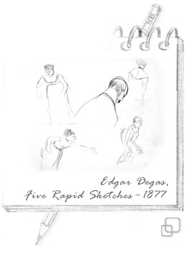
In this week, we will cover the figure in movement. We will explore a variety of approaches to the technique to depict movement and improve gesture drawing skills.
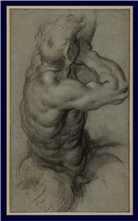
Portraying a figure that is moving is difficult for several reasons. The speed necessary to complete the entire form often leads to the inability to continually correct what you are drawing. It is difficult for the model to hold the pose for an extended period. However, these reasons are actually quite conducive to creating dynamic figure drawings. The quicker you can train your hand and eye to coordinate, the better able you will be to depict figures accurately and successfully. A key to dynamic figure drawing is to give the appearance that it took only a few seconds or a few minutes to complete the drawing of the pose. The more relaxed and less labored the approach, the more exciting and dynamic the result.
Drawing a moving figure can result in two types of drawings: a study or a final rendering. Consider each of the above drawings by Degas and Caracci. Notice the differences between the two, including the amount of time spent on the pieces and how each artist conveyed a moving figure. The Degas drawings are studies for a finished piece, whereas the Caracci figure looks like a finished, final rendered drawing.

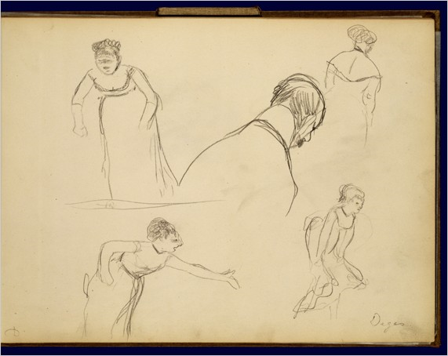
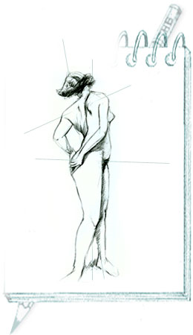
The foundation of drawing the moving figure is the gesture drawing. If the gesture of the pose is not accurately depicted, the figure will be off or lack dynamics. Therefore, we will go through several concepts and exercises to expand your approach to gesture drawing.

Balance
Balance is one of the most important elements to depict correctly in your drawing. Even in the most extreme motion there must be a sense of security, a sense that like a pendulum the figure will come back to its fixed center of gravity. This feeling or sense of balance should be conveyed through the flow and sweep of your drawing. It is the flow of your drawing that gives the figure the sense that the moving figure will not fall over. The way the human body stays in balance is based on where the head is related to the location of the feet. Therefore, before each pose draw a series of lines to portray this relationship.

Rhythm
George Bridgeman, author of Bridgeman's Life Drawing, stated that in order, "To express rhythm in drawing a figure we have in the balance of masses a subordination of the passive or inactive side to the more forceful and angular side in action, keeping constantly in mind the hidden, subtle flow of symmetry throughout." The rhythm of the figure must always be a depiction of the forms in relation to one another.

Harmony
The masses of the body can be divided into several key areas. These include the head, chest, and pelvis. Each has its own unique dimensions. As masses they are linked together by the spinal column. They can each twist and turn, with the spaces between them becoming long or short depending upon the pose. These masses are moved by muscles, tendons, and ligaments. The muscles are paired together in groups and perform in the active and passive realms for each movement. You cannot have a taut, tight muscle working hard to perform or hold up a part of the body without the relaxed or passive side opposing this movement. This opposing yet partnered relationship is the essence of movement.

Moving Figures in Various Media

Both drawings from the Renaissance are beautiful examples of figures appearing to be in movement. Drapery can be an effective element to use to show the direction of the pose and to give the illusion of a form moving in space. Passarotti achieves the illusion that the same figure is moving across the page by drawing a multiple figure study composition in the same plane. Also note the media used, which are a combination of washes and drawing tools on toned paper. Experiment with several types of media for your next exercises.


Try each of these approaches to expand your approach to gesture drawing:
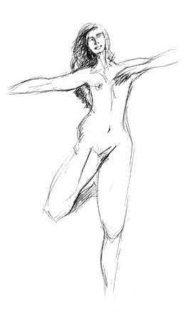
- Have your model strike several exaggerated poses that depict the illusion of movement. Examples include standing on one leg, reaching for an object, kneeling at an angle, etc.
- Use graphite, eraser, and graphite stick on white paper. Draw the figure in a series of different size rectangular blocks. Represent each form separately and in proportion to one another. These include the head, neck, arms, legs, pelvis, ribcage, hands, and feet. Once the big blocks are in, break the figure up into smaller blocks. Do not round the forms.
- Use charcoal, eraser, blending stump, and white conté. Using the side of a piece of charcoal or conté crayon, draw the figure from a volume perspective. Depict the figure in a series of curved volume strokes. Think of the Michelin Tire Man as a guide. Have the strokes follow the direction of the forms. Vary the weight of your strokes to convey light and dark. Do not use the sharp end of the tool.
- Use both pen and ink or black sharp marker with a light gray ink wash. Draw a series of shapes and lines to represent the line of gravity and balance of the pose. Use an oval for the head and draw a straight line to the feet. Use a curved line for the back.
- Use conté crayons on toned paper. Oftentimes we tend to flatten out or use straighter lines than the pose actually calls for. By overexaggerating you should see more dynamic looking poses start to appear. Overexaggerate/emphasize the poses taken by your model. Draw each element more angled and dramatic than it actually seems.

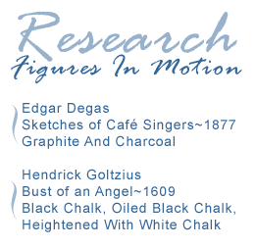
Degas and Goltzius
Movement can be displayed in a drawing in both portraiture and whole figure studies. After searching for the works of art referenced in the sidebar of this page, compare the drawings by Goltzius and Degas to see how each artist adds to the sense of movement in each drawing.

Degas
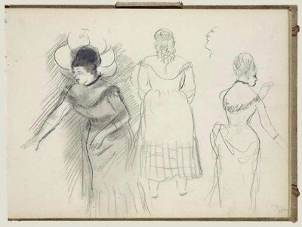
The use of angles and placement of the figures on the page are the main elements in this series of figures to give the illusion that the Café Singers are each in mid-song. By capturing the moment when each singer appears to be hitting a particular note, Degas has brought us into the café to the point where we can almost hear the music. Degas studied singers and dancers and took careful note of their body language and how they held themselves while executing their craft. The singer on the right appears to be more restrained and singing a softer tone due to her erect posture and placement of her arms and hands. The strong angles of her arms and hands as opposed to her straight posture are directing the performance and offer a compelling depiction of the importance of opposites. The singer on the left, however, appears to be singing in full voice, more at the climactic point of her piece. The strong diagonal of the right arm in opposition to the relaxed position of the left and her angled posture add to the sense that she is giving the song her all out effort. The figure in the center offers a nice compositional element to make this series a beautiful study in the contrasts of the body in a singing performance.

Goltzius
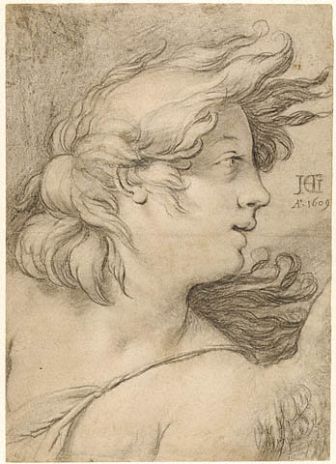
The portrait by Hendrick Goltzius offers a view of an angel that appears to be in mid-flight or caught on a windy day. The glance of the eyes going sideways and to the right of the page, as well as the hair flying away from the face, are two very strong elements to help with this illusion. The angle of the shoulders is very sharp and gives a strong diagonal to offset the horizontal gaze of the angel. This piece is more fully realized than the Degas sketches, yet it still seems spontaneous with a strong illusion of movement.

Moving Figures in Historical Drawings
Elements to consider when analyzing an historical art source in depicting movement:

What is the primary composition?
- Is it cropped as in the Goltzius piece, or is it a series of multiple subjects as in the Degas?
- Where are the figures placed and how does that make the composition stronger?
- Note the Goltzius shoulders/arms are cropped at two different points (left side and bottom) to add to the strong diagonal.
- In the Degas composition, the three figures are slightly offset to give a stepped composition that is more interesting to the eye than a straight linear horizontal plane.

What is the use of angles and diagonals?
- How do they help to lead the eye around the page and not become stuck in any one place?
- Notice in the Degas piece that the arm on the left side of the page leads to the eye which leads to the strong darkness of the hair which brings us to the center figure and back down to the figure on the right.
- The angle is an upside down curve that leads the eye around to take in the entire composition.
- The Goltzius piece has a straight horizontal of the hair and gaze of the eye that is juxtaposed with the strong diagonal of the shoulders.

How did the artist juxtapose the contrast?
- Where are the strongest darks and lights, and how does that lead the eye around?
- The darkness in the hair of the left side Degas figure offsets the lighter, sketchier qualities of the two right side figures.However, even though they are less rendered, the figures carry their own weight due to the strong lines and diagonals.
- The Goltzius piece is more fully realized in terms of lights and darks.

Composing a Moving Group Figure Drawing
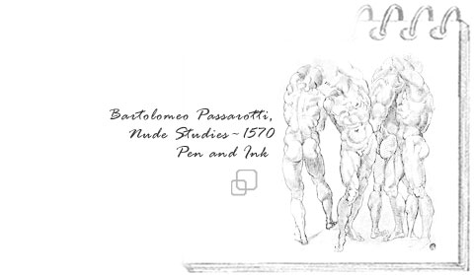
The composition of a group in movement can be an exciting one in figure drawing. However, drawing one figure is often quite a challenge when that figure is moving. How does one depict a group? In both of the above pieces, each artist probably used the same model in different poses to give the illusion of a group of figures. In the Passarotti piece, the bodies of the male figures are very similar to each other. However, since they are posed at different angles and composed in an interlocking manner, it appears to be a group of four men in mid-pose. The Dali nudes add a more dynamic group composition due to the impression that if the three women were not holding hands they would all fall down. The tension in the arms is one of the key elements to tell the story.
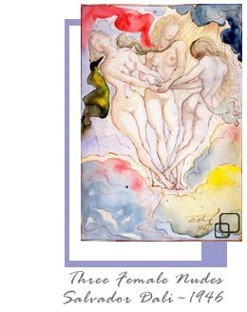

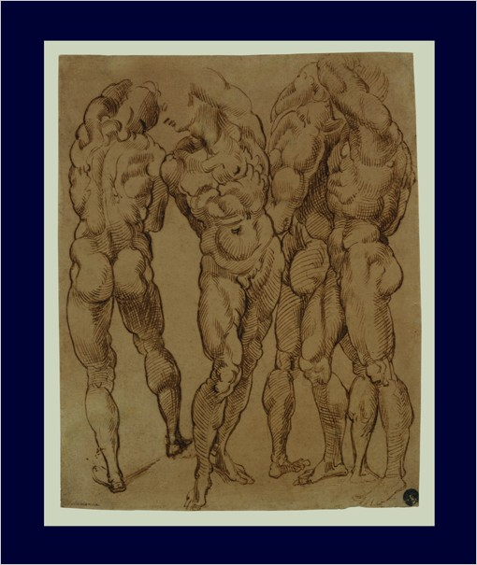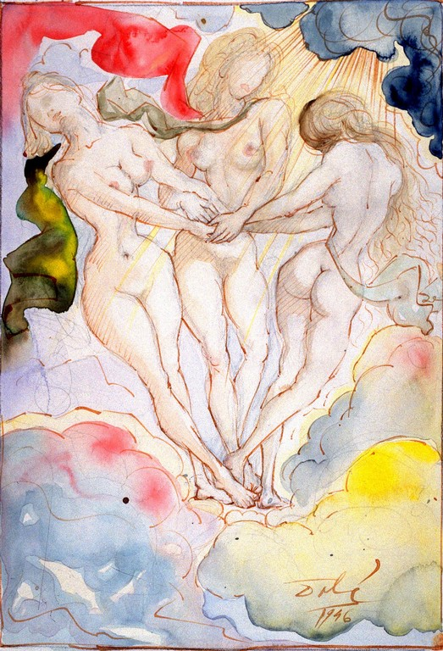

Finished Drawing of a Moving Figure
As is clear in both of these drawings, using a figure that appears to be moving can also be the subject of a finished drawing rather than just a series of sketches or studies. However, keeping the drawing fresh and alive while working slower and more deliberately is the challenge.
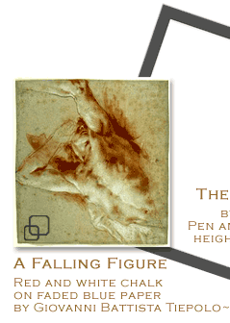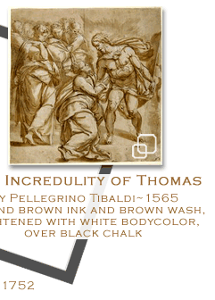
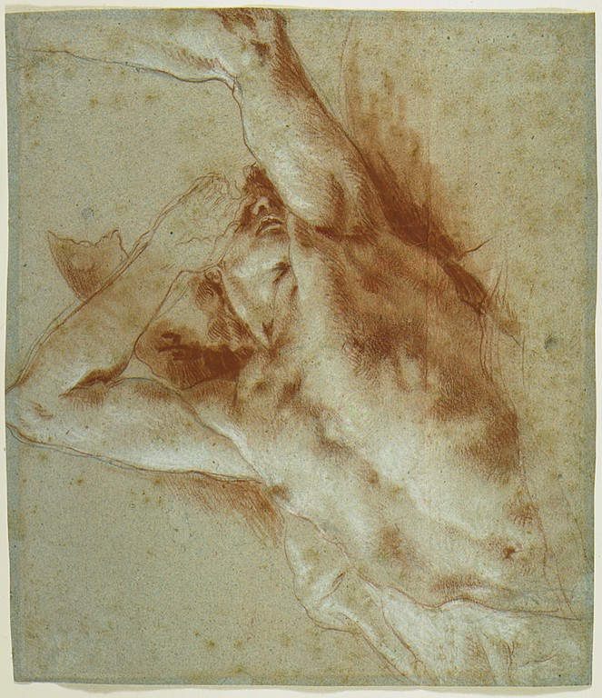
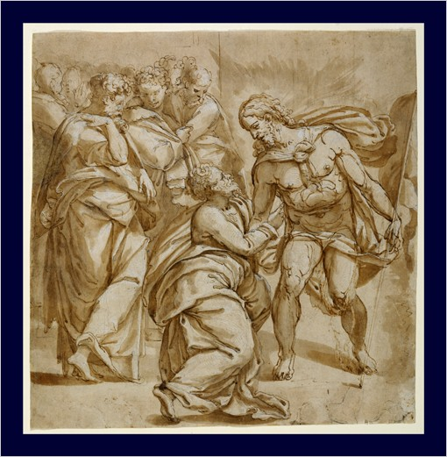

Assignment 1: Using a Variety of Materials to Depict the Moving Figure
Part 1: Drawing
Have your model strike several exaggerated poses that depict the illusion of movement. Examples include standing on one leg, reaching for an object, kneeling at an angle, and so on. Submit at least 4 of the best poses.
Complete a gesture drawing using various materials as mentioned in the lecture.
Review pp. 108–113, 116–119, and 144–149 in Dynamic Figure Drawing by Burne Hogarth
Scan or shoot your drawings with a digital camera and save the image as a jpeg file. Submit your drawings, by Tuesday, October 28, 2008, to the appropriate topic in this Discussion Area.
Part 2: Discussion
After you submit the drawings, respond to the following question. Post your response to the appropriate topic in this Discussion Area by Tuesday, October 28, 2008. Review and critique the work of at least two other students early in the week, and submit it to the Discussion Area. You can ask questions or respond generally to the overall experience. You may include examples, demonstrations, and illustrations, where applicable. Ensure to be honest, clear, and concise. Always use constructive language, even in criticism, to work towards the goal of positive.
- How did you find your approach to gesture drawing change with the assignments and use of media? Did you make any new discoveries in either media or approaches?
Grading Criteria: | Maximum Points
Forms were accurate. | 4
Used a variety of materials for achieving the desired effect. | 4
Submitted the assignment on time. | 4
Actively participated in the discussion. | 4
Student used terminology and relates concepts introduced in course studies throughout discussion contributions. | 4
Total: | 20
For assistance with any problems you may have when completing this assignment—OR—to offer your assistance to classmates, please use the Problems and Solutions Discussion area located through the left side navigation link.
Part 1 – Drawing: Remember-this one is about representing movement.
Part 2 – Discussion
- How did you find your approach to gesture drawing change with the assignments and use of media? Did you make any new discoveries in either media or approaches?
Assignment 2: Using Art Historical Sources to Depict Gesture Drawings and a Figure in Movement
Part 1: Drawing
Copy the drawing by Goltzius and Degas coming as close to the original as you can. Try to stay as loose as possible, particularly when copying the Degas drawing. Start off with a quicker sketch and then go for a more rendered approach.
You will be graded by your ability to accurately depict each piece in terms of movement, accuracy of the composition, and attention to the elements in depicting movement.
By Thursday, October 30, 2008, scan or shoot the drawings with a digital camera and save the image as a jpeg file. Submit the files to the appropriate topic in this Discussion Area.
Part 2: Discussion
Compare the drawings by Goltzius and Degas to see how each artist adds to the sense of movement in each drawing. Share your observations with your fellow classmates. Post your observations the appropriate topic in this Discussion Area by Thursday, October 30, 2008. Review and critique the work of at least two other students early in the week, and submit it to the Discussion Area.
Grading Criteria: | Maximum Points
Accurately depicted each piece in terms of movement. | 4
Composition was accurate. | 4
Paid attention to the elements in depicting movement. | 4
Assignment submitted on time. | 4
Actively participated in the discussion. | 4
Student used terminology and relates concepts introduced in course studies throughout discussion contributions. | 4
Total: | 24
For assistance with any problems you may have when completing this assignment—OR—to offer your assistance to classmates, please use the Problems and Solutions Discussion area located through the left side navigation link.
Part 1 – Drawing: Again-your are coying so get it as close as possible to the originals.
Part 2 – Discussion
Compare the drawings by Goltzius and Degas to see how each artist adds to the sense of movement in each drawing. Share your observations with your fellow classmates. Post your observations the appropriate topic in this Discussion Area by Thursday, October 30, 2008. Review and critique the work of at least two other students early in the week, and submit it to the Discussion Area.

Assignment 3: Composing a Moving Group Figure Drawing
Review Chapter 2, pp. 44–64 in Dynamic Figure Drawing by Burne Hogarth
Complete this assignment and your drawing to the appropriate topic in this Discussion Area, by Thursday, October 30, 2008. Post only the final group gesture sketch here in the discussion.
Scan or shoot the drawings with a digital camera and save the images as a jpg file.
- Have your model do several different types of dynamic poses. For example, a full twist, reaching for an object, and so on. Draw several gesture studies of your model in movement on the same page. Keep the figures in the same proportion to one another and use the same materials and technical approach. Stay consistent.
- Select from the gesture drawings 3 or 4 poses that would look good as a group composition. While you do this try to think which is the most dynamic composition? A straight linear path? A stepped composition? Would cropping or having certain parts of the figure off the page add interest? Then create a final sketch with the 4 poses. Take no longer than 20 minutes to complete the final group gesture sketch.
Part 2: Discussion
After you submit the drawings, respond to the following question. Post your response to the appropriate topic in this Discussion Area, by Thursday, October 30, 2008. Review and critique the work of at least two other students by the end of the week, and submit it to the Discussion Area. You can ask questions or respond generally to the overall experience. You may include examples, demonstrations, and illustrations, where applicable. Ensure to be honest, clear, and concise. Always use constructive language, even in criticism, to work towards the goal of positive.
- How do you maintain the balance in a figure drawing? Discuss you viewpoints on this issue
Grading Criteria: | Maximum Points
Accurately depicted each piece in terms of movement. | 4
Paid attention to the elements in depicting movement. | 4
Assignment submitted on time. | 4
Actively participated in the discussion. | 4
Student used terminology and relates concepts introduced in course studies throughout discussion contributions. | 4
Total: | 20
For assistance with any problems you may have when completing this assignment—OR—to offer your assistance to classmates, please use the Problems and Solutions Discussion area located through the left side navigation link.
Part 1 – composing a group figure drawing: This one is all about making a wise arrangement. Try several before you decide.
Part 2 – discussion
- How do you maintain the balance in a figure drawing? Discuss you viewpoints on this issue

Assignment 4—Making a Moving Figure Sketch into a Finished Drawing
Review pp. 95–104 in Dynamic Figure Drawing by Burne Hogarth
Use your model or a pose from the Virtual Pose CD-ROM and create your best composition of a figure that appears to be in movement. Draw a value scale of 12 boxes from white to black with shades of gray in between. Be sure that each value is represented in your drawing. Please describe your shading technique.
This is meant to be a final rendered drawing and should take you at least 1–2 hours to complete. Scan or shoot the drawings with a digital camera and save the image as a jpeg file. Submit it to this Discussion area by Saturday, November 1, 2008.
Review and critique the work of at least two other students by the end of the week, and submit it to the Discussion Area.
Grading Criteria: | Maximum Points
Rendered a finished figure in movement. | 4
Figure was composed and approached with a dynamic perspective. | 4
Assignment submitted on time. | 4
Participated in the discussion with concise and clear comments. | 4
Student used terminology and relates concepts introduced in course studies throughout discussion contributions. | 4
Total: | 20
For assistance with any problems you may have when completing this assignment—OR—to offer your assistance to classmates, please use the Problems and Solutions Discussion area located through the left side navigation link.
Remember this one is "finished". Be sure it meets the criteria.

